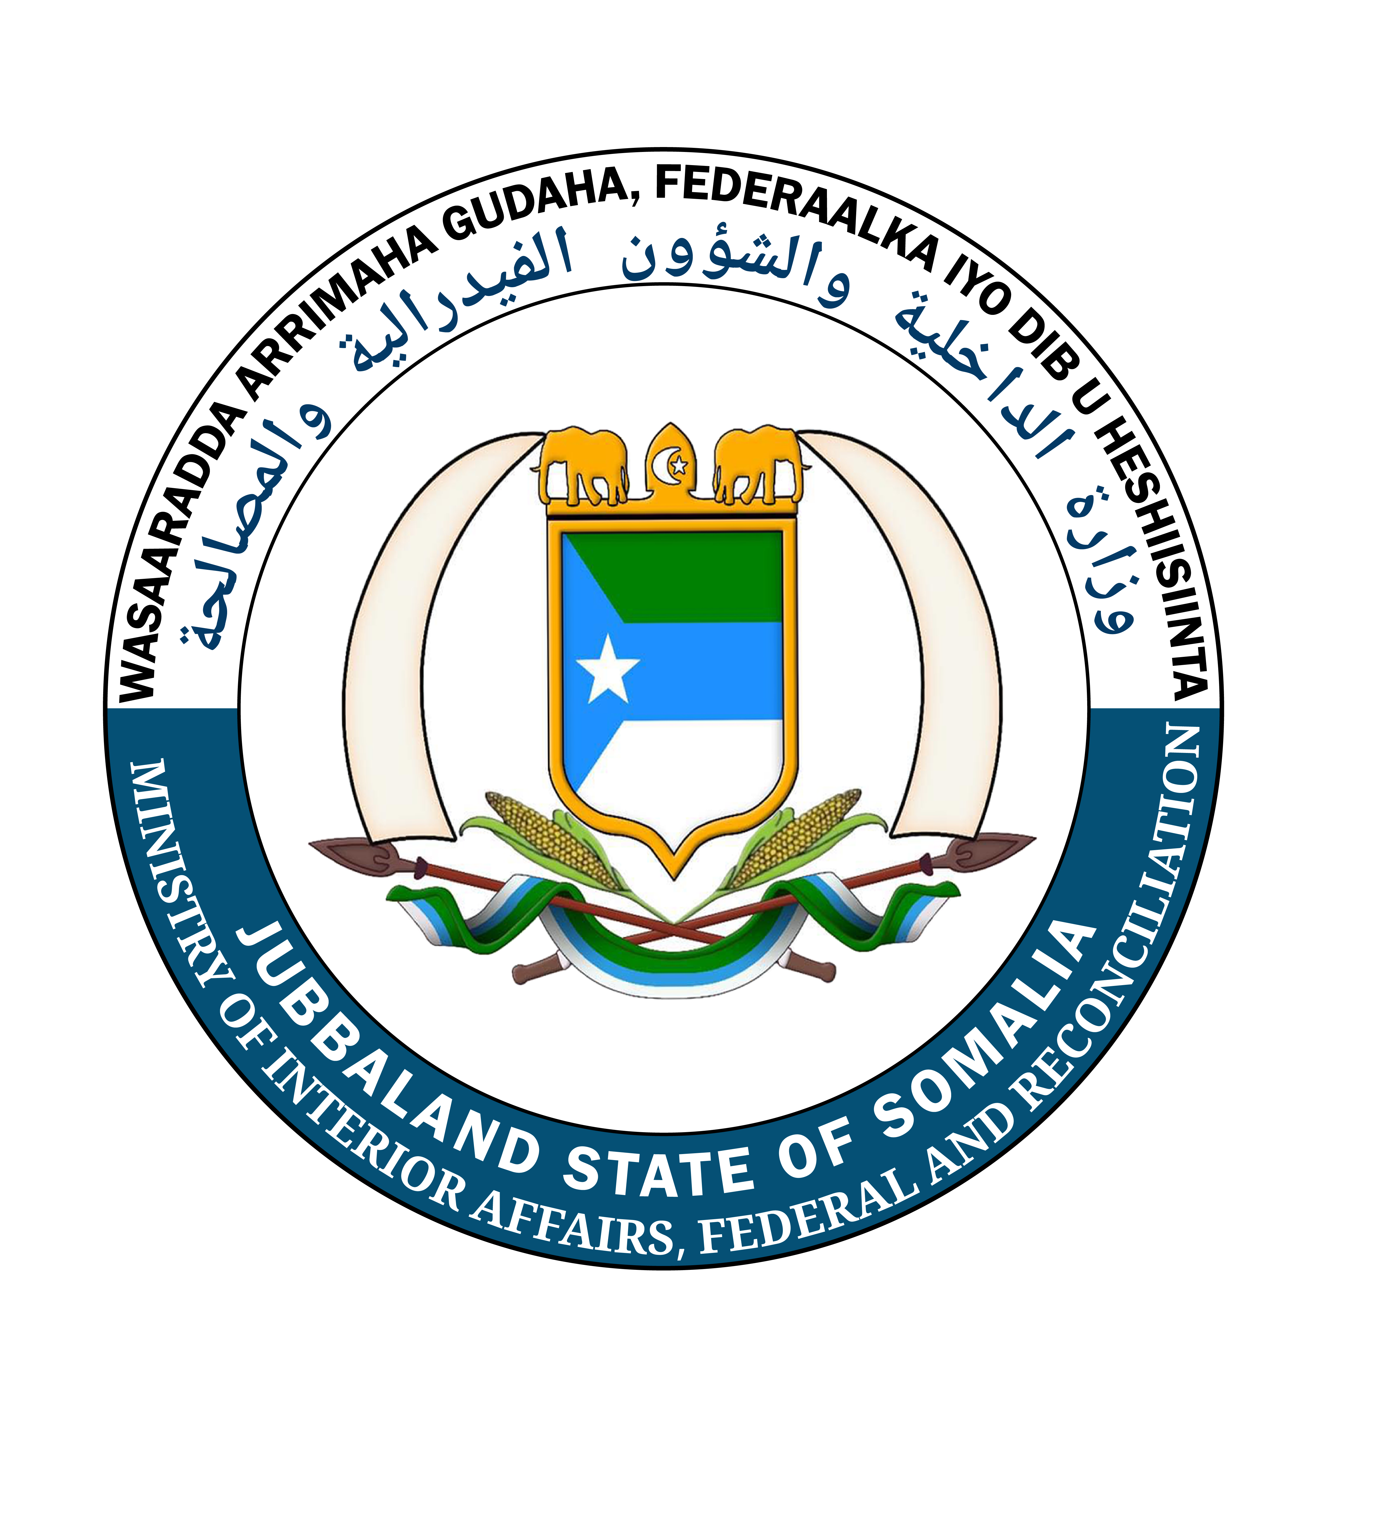
دولة إقليم جوبالاند الصومالية
وزارة الداخلية والشؤون الاتحادية والمصالحة
مكتب المدير العام

DOWLAD GOBOLEEDKA JUBBALAND EE SOOMAALIYA
WASAARADDA ARRIMAHA GUDAHA, FEDERAALKA IYO DIB U HESHIISIINT
Xafiiska Agaasimaha Guud

JUBALAND STATE OF SOMALIA
MINISTRY OF INTERIOR, FEDERAL AFFAIRS AND RECONCILIATION
Office of General Director

VACANCY ANNOUNCEMENT
Ministry of Interior, Federal Affairs and Reconciliation – Jubaland State
Position Title: | District Capacity Building Consultant
Type of Contract: | Individual Consultant
Duty Station: | Kismayo District, Jubaland State
Duration of Assignment: | 3 months, with possible extension subject to fund availability
Reports To: | District Executive Secretary and Mayor
Programme: | Joint Programme on Strengthening Local Governance and Decentralized Service Delivery (Dowlad-Kaab Programme) – UNDP, UNICEF, and UN-HABITAT, funded through the Somalia Joint Fund
Submission Deadline: | 22nd June 2026

Background
The Dowlad-Kaab Programme is a five-year joint initiative by UNDP, UNICEF, and UN-HABITAT, funded through the Somalia Joint Fund, aimed at strengthening local governments to effectively respond to the needs and rights of all citizens, with particular attention to women, youth, and marginalized groups. The programme supports the Ministry of Interior in institutionalizing the district development framework process and ensuring that community priorities are incorporated into district-level service delivery plans.
Key focus areas of the programme include enhancing local government capacity for responsive service delivery, promoting inclusive and participatory governance (including e-governance), strengthening transparency and accountability, and developing sustainable, context-specific strategies for each Federal Member State.
The Ministry of Interior, with support from the Dowlad-Kaab Programme, is seeking a qualified District Capacity Building Consultant to be based at the Ministry of Interior and to provide technical and on-the-job capacity building support to District Departments in Kismayo.

Objective of the Assignment
The Capacity Building Consultant will provide technical assistance and extensive on-the-job training to District Departments, building their capacity to deliver services and manage decentralization processes as part of the ongoing local government reform process. Support will cover local government planning, management, administration, financial management, procurement, human resources, and Public Expenditure Management (PEM), including the preparation of the District Development Framework (DDF) and Annual Work Plans and Budgets (AWP/B).
This is a performance-based position with an initial probation period of 3 months. Performance will be assessed quarterly by the Ministry of Interior and Local Government (MOILG) with support from UNDP/Dowlad-Kaab, with monthly payments based on delivery of required outputs. Contract renewal will depend on achievement of the tasks outlined in the Terms of Reference.

Key Responsibilities
- Provide technical support and capacity development to District Departments to strengthen their ability to fulfil their mandates.
- Conduct periodic Training Needs Assessments and recommend measures to address identified gaps.
- Support district departments, particularly the Planning Department, in coordinating capacity building activities.
- Provide technical support for the implementation of Public Expenditure Management (PEM) and the preparation of the DDF and district Annual Work Plan and Budget.
- Support capacity building in financial management, budgeting, procurement, administration, office management, and human resource management.
- Facilitate knowledge building, skills acquisition, and on-the-job training at the district level.
- Support organizational restructuring and the development of operational policies and procedures for effective performance and service delivery.
- Prepare a detailed work plan within the first six weeks of the assignment, approved by the Director of Local Government, and submit monthly, quarterly, and annual reports.

Required Qualifications and Experience
- University degree in Public Administration or a related field.
- At least 5 years of relevant experience at the national or international level.
- Proven experience in capacity development and implementation.
- Experience with computers and office software packages (MS Word, Excel, etc.).
- Experience in administration, finance, and human resource management.
- Self-driven, detail-oriented, and able to work with minimal supervision while ensuring transparency and accountability.

Language Requirements
Fluency in English and Somali, both written and spoken, is required.

How to Apply
Interested and qualified consultants are invited to submit the following documents:
- Updated CV highlighting relevant experience.
- Cover Letter outlining your suitability for the assignment and proposed approach.
- Submission: Applications should be submitted directly to the Ministry of Interior office.
The Ministry of Interior and Local Government -Jubaland State and UNDP-Dowlad-Kaab focal point,
Only be able to respond to those applications in which there is further interest.

Women are strongly encouraged to apply.

